**What is Git.**

**it** is an **open-source distributed version control system**. It is designed to handle minor to major projects with high speed and efficiency. It is developed to co-ordinate the work among the developers. The version control allows us to track and work together with our team members at the same workspace

**What is Git hub.**

GitHub is an online software development platform. It's used for storing, tracking, and collaborating on software projects. It makes it easy for developers to share code files and collaborate with fellow developers on open-source projects.

**What is Difference Between git and git hub.**

Git is a version control system that lets you manage and keep track of your source code history. GitHub is a cloud-based hosting service that lets you manage Git repositories

**What is Difference between Google drive and Git hub.**

* GitHub is a place to share code with friends, co-workers, classmates, and complete strangers, helping individuals and teams to write faster, better code
* Google Drive is a cloud storage and backup platform to access files, docs, photos & more, store them in a safe place , and collaborate with other people

Git hub is mainly for version control of source code, not for file storage. If you want to store things like Word documents, media files, PDFs, and so on, stick with Google Drive .

**What is Jira software.**

Jira Software is a project management tool developed by Atlassian specifically designed for agile software development teams . It offers a variety of features to help teams plan, track, and release software projects. Here are some of the key uses of Jira Software:

* **Agile project management:** Jira Software supports various agile methodologies, including Scrum and Kanban. It provides features like customizable boards, sprint planning tools, and backlog management to help teams visualize workflows and track progress efficiently [
* **Bug tracking and issue tracking:** Jira is a powerful tool for identifying, reporting, and fixing bugs in software development. It allows teams to create and assign issues, track their progress, and prioritize them based on severity
* **Requirement and test case management:** Jira acts as a central hub for managing all aspects of the software development lifecycle. It helps teams manage requirements, create test cases, and integrate with various quality assurance tools.
* **Improved collaboration:** Jira fosters collaboration within software development teams. Team members can discuss issues, share files, and stay updated on project progress in real-time.
* **Reporting and analytics:** Jira provides reporting and analytics tools to help teams gain insights into project performance. This data can be used to identify bottlenecks, improve efficiency, and make data-driven decisions.

Overall, Jira Software is a versatile tool that can be used by software development teams of all sizes to streamline their workflows, improve collaboration, and deliver high-quality software.

What is the Agile methodology?

The Agile methodology is an approach to software development that emphasizes flexibility, collaboration, and incremental progress. It is based on the Agile Manifesto, which outlines four core values and twelve principles that guide Agile practices. Here is an overview of the key aspects of Agile:

1. **Individuals and interactions over processes and tools**: Agile values communication and collaboration among team members more than relying solely on tools and processes.
2. **Working software over comprehensive documentation**: While documentation is important, Agile prioritizes delivering working software to customers frequently and iteratively.
3. **Customer collaboration over contract negotiation**: Agile promotes active involvement of customers and stakeholders throughout the development process to ensure the final product meets their needs.
4. **Responding to change over following a plan**: Agile acknowledges that requirements and priorities can change, so it prioritizes adapting to changes quickly and effectively.

Agile methodologies, such as Scrum, Kanban, and Extreme Programming (XP), provide specific frameworks and practices for implementing these principles. These frameworks typically involve iterative development cycles, frequent feedback loops, cross-functional teams, and continuous improvement processes. Agile is widely used in software development but has also found applications in other fields due to its emphasis on flexibility and customer-centricity

**What is S.D.L.C**

**Software development life cycle (SDLC) is a structured process that is used to design, develop, and test good-quality software.** SDLC, or software development life cycle, is a methodology that defines the entire procedure of software development step-by-step.

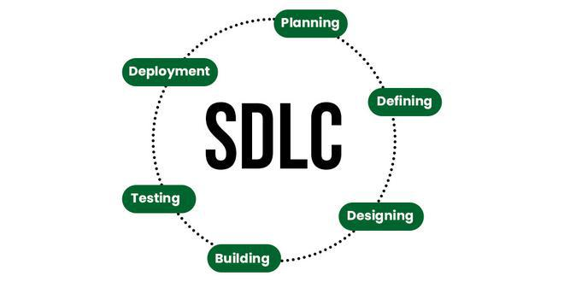

## What is Software Development Life Cycle (SDLC)?

**SDLC is a process followed for software building within a software organization.**SDLC consists of a precise plan that describes how to develop, maintain, replace, and enhance specific software. The life cycle defines a method for improving the quality of software and the all-around development process

## Stages of the Software Development Life Cycle

SDLC specifies the task(s) to be performed at various stages by a software engineer or developer. It ensures that the end product is able to meet the customer’s expectations and fits within the overall budget. Hence, it’s vital for a software developer to have prior knowledge of this software development process.

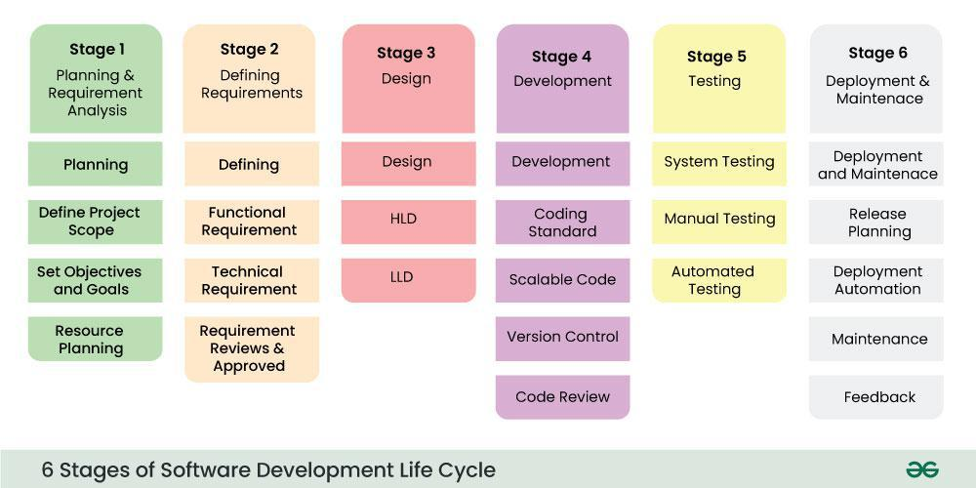

## What is the water methodology.

## The waterfall methodology is a project management approach that emphasizes a linear progression from beginning to end of a project. This methodology, often used by engineers, is front-loaded to rely on careful planning, detailed documentation, and consecutive execution.

## The Waterfall methodology — also known as the Waterfall model — is a sequential development process that flows like a waterfall through all phases of a project (analysis, design, development, and testing, for example), with each phase completely wrapping up before the next phase begins

